You Ought to be in Pictures:

Bringing Streaming Video to Your Library

Cheri Duncan and Erika Peterson

James Madison University

Since 2003, James Madison University has been building a streaming video collection. Using vendor licensing and fair use guidelines, the University Libraries’ have added thousands of online videos via either purchased files or in-house digitization. Whether through media collections or title by title, the Libraries strive to provide faculty and students with access to the resources they require at the time and place they need it. The Libraries’ efforts in building and maintaining this collection from selection to licensing and from digitization to access over the last seven-eight years has presented numerous learning opportunities and eye-opening moments. Through their experience, Libraries’ staff have utilized systems and multiple workflow evaluations to streamline processes and procedures. In addition, aspects of the process have evolved with technology and as more vendors enter the world of digital rights. Still, the act of streaming media for use within an academic setting is a complex, multi-step process. However, the Libraries’ have found the pay-off for its efforts to be well worthwhile.

1. **Introduction**

Since 2003, James Madison University has been building a streaming video collection in an effort to provide faculty and students with their preferred method of access to quality videos. As with e-journals, e-books, and electronic databases, streaming media requires a substantial number of additional steps to acquire and manage than tangible formats. The basic life cycle of a streaming video has five main components: acquisition, access, administration, support, and evaluation.

**Figure1. Streaming Video Life Cycle**

Each of these five major components consists of numerous steps and elements. This paper will attempt to highlight those steps which are most intricate or unique to streaming video and the “best practices” associated with various aspects of a digital video collection.

1. **Acquisition**

The Acquisitions process from selection to receipt and payment are similar to those of other library materials. However, there are a few additional elements of which to be aware.

* 1. **Needs Assessment & Selection**

Faculty recommendation and usage statistics are the two most important factors in selecting individual titles for streaming. Because of the cost prohibitive and time consuming nature of streaming licenses, DVD continues to be the default format for the majority of film purchases. However, as faculty become more familiar with streaming video through services like Netflix, iTunes and Amazon Instant, requests for streaming materials are increasing. There are several common scenarios that would result in a streaming licenses being requested.

1. A faculty member identifies a new title and requests that the title be purchased and made available to her students in the electronic course management system, i.e. Blackboard, Moodle, etc.

2. A faculty member requests that a title already available in a physical format in the collection be made available streaming.

3. The media librarian or reserve specialist identifies a title, which because of high circulation or frequent reserve requests, warrants a streaming license. In this case a streaming license would be acquired in lieu of purchasing an additional physical copy.

Rarely, would the first purchase of a title be made with streaming rights if the request didn’t originate with a faculty member.

When evaluating a subscription package for purchase the criteria are by necessity somewhat different than the selection of individual titles. The initial request is likely to begin with a subject liaison librarian and result in a trial for the product. During the trial librarians and faculty members in relevant departments would be asked to evaluate the product and submit feedback. If the collection includes titles the library owns a physical copy of, the media resources staff would evaluate the use and impact of the existing titles. After the trial a purchase recommendation would be made and the resource would be considered along with any other new databases or other digital content that has been recommended for purchase. The JMU libraries currently subscribe to Films Media Group’s Films On Demand and several of Alexander Street Press’ catalogs including most recently Filmmakers’ Library Online.

* 1. **Price Negotiation, Licensing, & Ordering**

Pricing and licensing vary depending on what exactly the library is purchasing. Is the interest in an archival DVD plus digital rights, in a streaming file only downloaded to the library’s server, or in access to the streamed video via the vendor’s server? Which of these options are available?

Often for single titles from smaller producers or distributors, a library will find that the only option is to purchase the DVD and the right to digitize the license for streaming to classes and authorized individual members of the library’s community. Since these purchases are usually made on a title-by-title basis, the vendor may require a license or simply a “shrink wrap” agreement which often consists of a statement regarding the purchase of digital rights on the invoice. The library may find that it wishes to purchase digital rights for a title or set of titles for which it already owns the VHS or DVD; this, too, may often be negotiated with the vendor from whom the title was originally purchased or the current rights holder. Should a library anticipate future digital rights purchases from the vendor, it is in the library’s best interest to negotiate a quantity discount. Such a discount may require the purchase of digital rights to a certain number of titles up front, for example, a purchase of digital rights for five (5) titles may lock the library in to a discount for all future digital rights purchases. Or, future discounts may be based on a sliding scale, using the total accumulated number of digital rights titles acquired from the vendor. Finally, if at all possible, the library will want to negotiate perpetual rights for the title if it’s going to pay a significant fee and complete the digitization work itself. With digital video rights, perpetuity is often phrased as “for the life” of the original format from which the video was digitized.

When purchasing a streaming file or files from the vendor, the library may or may not wish to also have within its collection an archival DVD, VHS, or Blu-ray. The streaming file itself becomes the original and a copy may be stored as an archival copy as long as the license agreement permits archival rights. The library, in this case, is responsible for hosting and serving the file on its own streaming media server. Typically the rights to host and present this vendor-created digital file are purchased for a three-, five-, or ten-year renewable period or as a perpetual license. Vendors may offer a long-term renewable license, a perpetual license, or the option of both. Once again, it is in the library’s best interest to negotiate an ongoing discount with those vendors from whom multiple individual rights or packages of rights will be ordered.

The third licensing model for streaming video consists of a hosted solution. Usually presented as subscription packages, such as subject or audience collections (i.e., business, social sciences, or academic) or as per hundred title purchases, larger video vendors are able to offer libraries access to streaming content from the vendor’s server or elsewhere in “the cloud.” Often there are tools included in the hosted system, which facilitates selection of clips for class use, mash-ups, and other features.

* 1. **Receipt & Payment**

The receipt and payment process for digital video rights may be quite different than that of other library acquisitions and require some adaptation on the part of staff and in workflows. For example, the library may simply receive an invoice for tangible video and the accompanying digital rights (or just the digital rights if the tangible copy was previously purchased). Either the library will have a license on file allowing digitization of the tangible copy or a statement on the invoice will indicate permission for the library to digitize the video. In either case, the library never receives a physical material for the digital rights. Therefore, audit trails, workflows, and other tracking mechanisms must be established to ensure that:

* + 1. The library has a tangible copy of the video that is of sufficient quality to digitize.
    2. Permission to digitize has been granted.
    3. A quality digital copy is created.
    4. The streamed video is accessible and viewable by the public.
    5. All of the above steps are properly recorded and findable within an ERM, an ILS, a database, a paper file or some combination of these.

When in this process the vendor is actually paid for the right to stream the video will depend upon the procurement, financial, and audit requirements of each institution. However, neither an individual staff member nor the library itself should be left in a position whereby payment is being rendered for rights to a title for which streaming is tenable at best. JMU Libraries recently devised a mechanism to close this audit hole by creating a tickler within the ILS that automatically notifies both Cataloging and Media staff when digital rights permissions or a digital file is “received” by Acquisitions, then notifies Acquisitions when the streamed file has been made available to patrons via the library catalog.

If the vendor provides a digital file, the file may be received via email, ftp, or, if purchasing a number of streaming videos simultaneously, shipped on a hard drive or USB key. Acquisitions staff must be technically savvy to receive the file in whatever format, check its integrity, work with the vendor to resolve any issues, and then forward the file to media services.

A hosted streaming video may be handled like any other e-resource. The vendor provides notification of access and Acquisitions staff confirm that the files are accessible and readable, resolving any issues with the vendor before announcing access to the appropriate parties.

1. **Access** 
   1. **Platform Implementation**

For hosted streaming video, the next step is setting up access through implementation of the platform. As with any e-resource, the library provides its IP range. Once the vendor has set up the library’s access, library staff should check or spot check the videos to which they have acquired access, testing to ensure the video loads and that streaming speed is satisfactory.

The library should then set up its options in the platform’s administrative module and check access through proxy, VPN, Shibboleth or other authentication methods.

* 1. **Digitization & Streaming**

Whenever possible it is preferable to acquire a digital copy of a film directly from the vendor as opposed to digitizing a DVD (either a library’s existing copy or one sent from the vendor for the purpose of digitization). Most obviously obtaining a digital file means staff time need not be devoted to digitizing the title. However, more importantly, a DVD contains an MPEG-2 file that has likely been compressed from a much higher quality MPEG-4 format. Acquiring the highest possible quality format ensures more flexibility with future improvements to delivery systems and a better viewing experience for the end user.

Vendors are not always able or willing to supply digital files or charge additional fees for these files that the library may or may not be willing to pay. In this case it is necessary to digitize from a DVD or much less desirably from VHS. More detailed information of the digitization process is included in the section on Hardware and Software needs and in Appendix A.

* 1. **Content Systems & Discovery Tools**

JMU libraries makes streaming video available via a variety of systems, including our library catalog, our discovery tool, and MDID, a home-grown, open source digital media management system.

The following three images are taken from the libraries’ catalog search. The first shows the dedicated search feature for videos, the second the results list (note this title is available as a DVD, as a local streaming file and through Films on Demand), the third image is of the video as displayed through MDID.

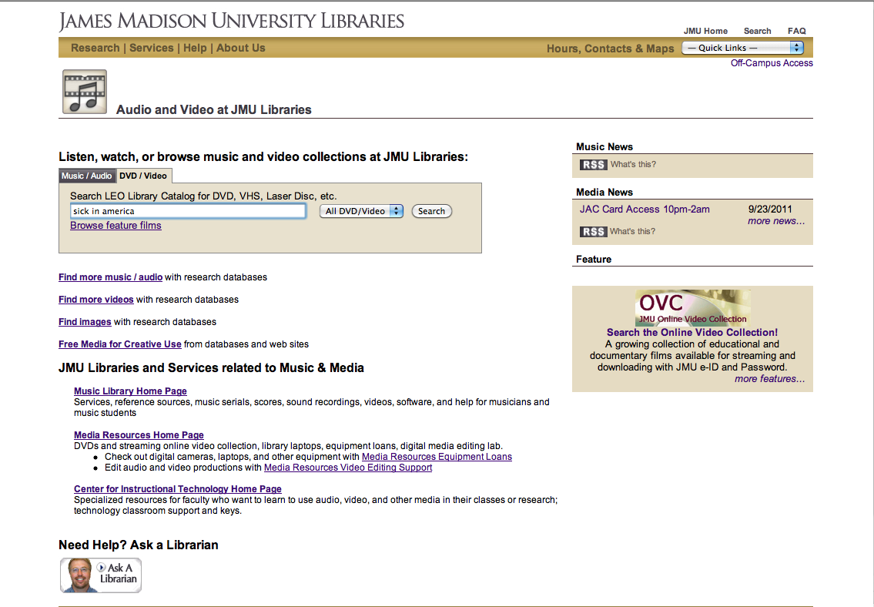

image 1

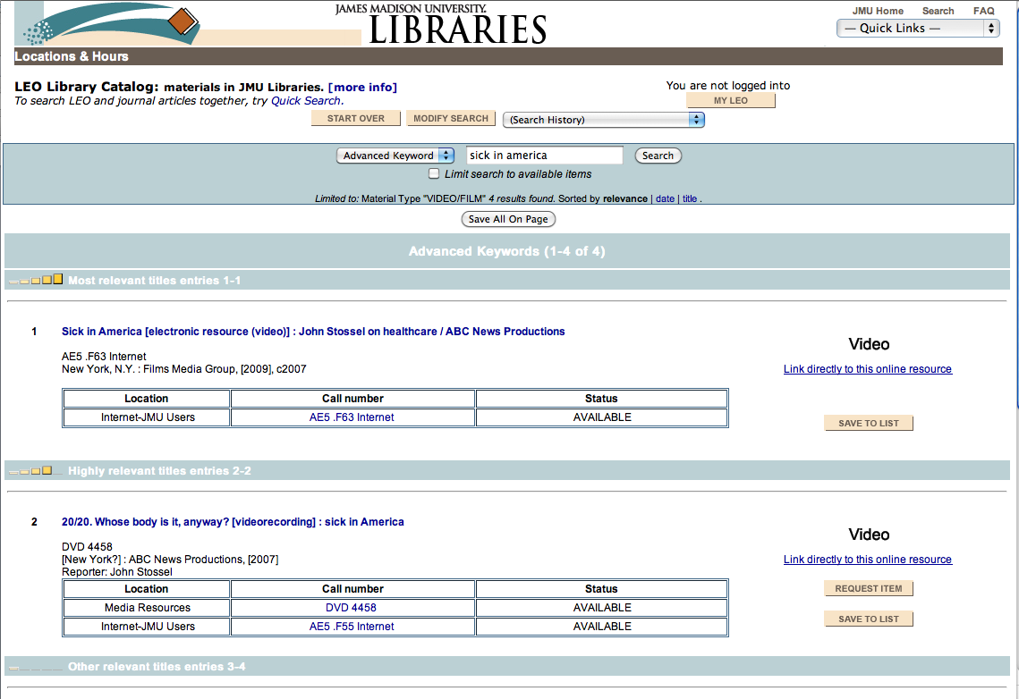image 2

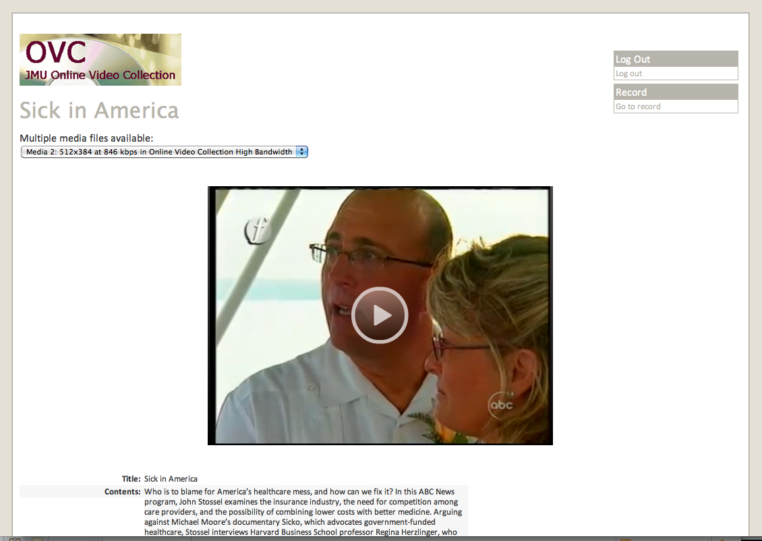

image 3

The image below is of the same title in the search results in the EBSCO discovery tool, and following that of the title displayed through Films On Demand.

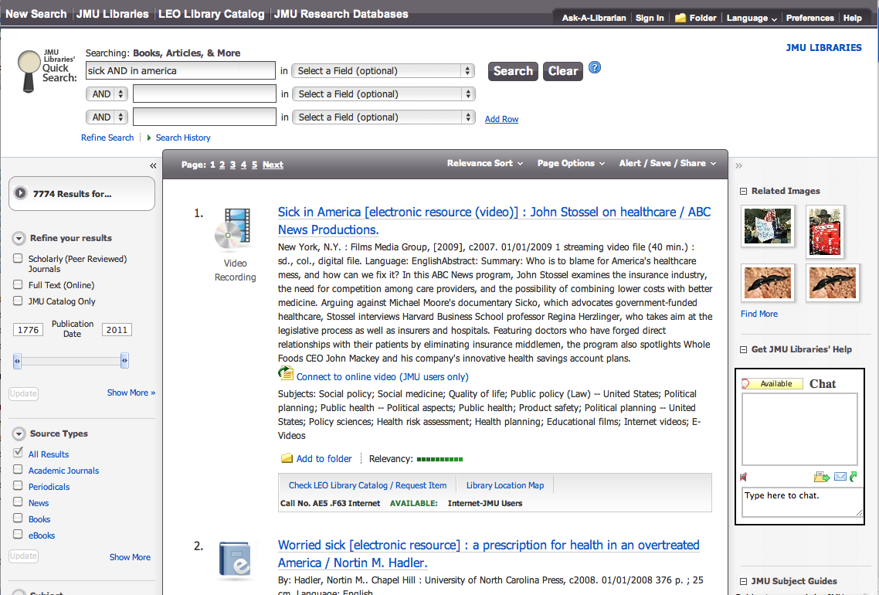

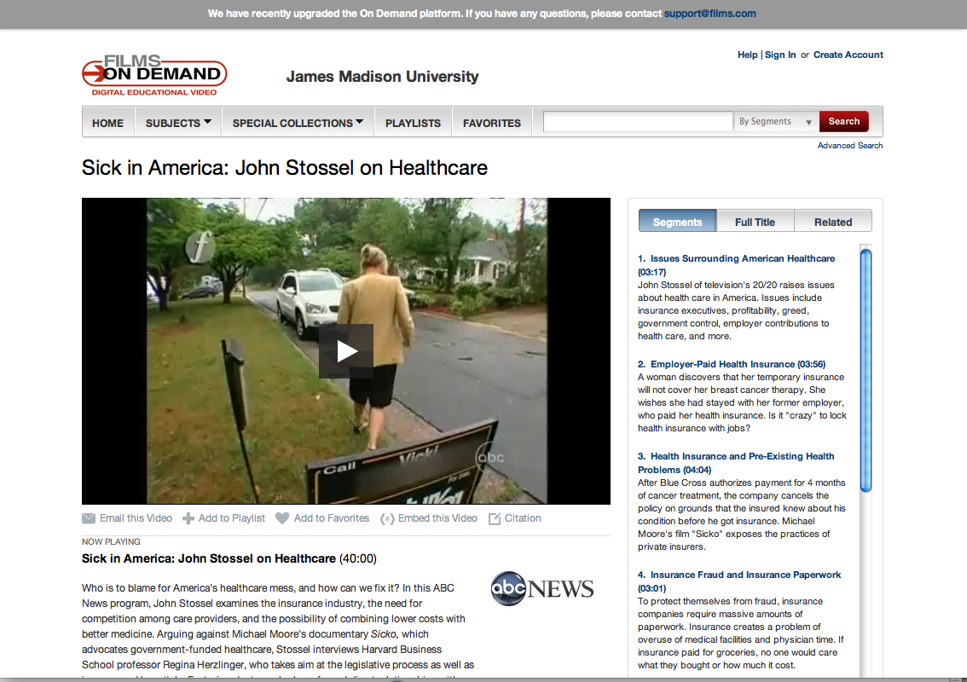

1. **Administration**
   1. **ERM**

JMU Libraries enters all administrative, technical, and licensing metadata for all electronic resources into its Electronic Resource Management (ERM) system. For streaming videos, this means that ERM can flag a resource with a renewal period and distribute a tickler to the designated party. No more having to manually track three and five-year contracts. Rights notations and discount commitments on invoices and confirmed via email are easily findable through electronic storage within the system. Administrative information, technical contacts, contract terms, archival information, etc. can all be readily stored in and access from ERM. With JMU’s ERM, usage guidelines stored in ERM can also be made visible to patrons.

* 1. **Class Use & Course Reserves**

Streaming video has had its largest impact on course reserve. The number of physical copies on reserve has dropped, partly in response to streaming video. Since one of our targets for the acquisition of streaming rights is class need, titles that are frequently on reserve are now more commonly available to faculty online. Additionally the number of requests from faculty for the acquisition of streaming rights for titles for class use has steadily increased. If a faculty member requests a reserve for a physical item that is also available streaming we include a link to the streaming item in their course reserve list. We will also inform them that it is available streaming so they may embed the film in Blackboard if they choose. It is likely that many faculty are doing this on their own, without library intervention, so it is difficult to know how many courses are using streaming video in this way.

In the event that a faculty member needs a title in streaming format and we are not able to purchase a license we are digitizing portions of the film for inclusion in Blackboard. These clips are made only under certain circumstances and not when an appropriate license is available for purchase or the title is available readily through a stable streaming format elsewhere. The files are available to students enrolled in the course only and are removed at the end of the semester. We are making constant adjustments to our criteria for approving such requests with the fluctuating legal climate around these services changes.

1. **Support**
   1. **Troubleshooting**

Troubleshooting issues with streaming media can impact several areas of the library, depending on several factors. Is the file locally or remotely hosted? How and where is the patron accessing the file? Is the library’s subscription, renewal information, technical information, etc. current? JMU Libraries utilizes a locally developed “Tech Support Form” to facilitate response to patron and staff inquiries and issues. This form, shown below, enables an individual to report an issue or request assistance with many services and resources, including streaming media. Once completed, the inquiry is distributed via email to a designated “support team” composed of members from various departments throughout the Libraries and based on the category selected. This eliminates the guesswork of who to contact and ensures a speedy response by a staff member who can troubleshoot the issue. If the primary response person is unavailable, a secondary tier of respondents will follow up with the patron and begin an investigation.

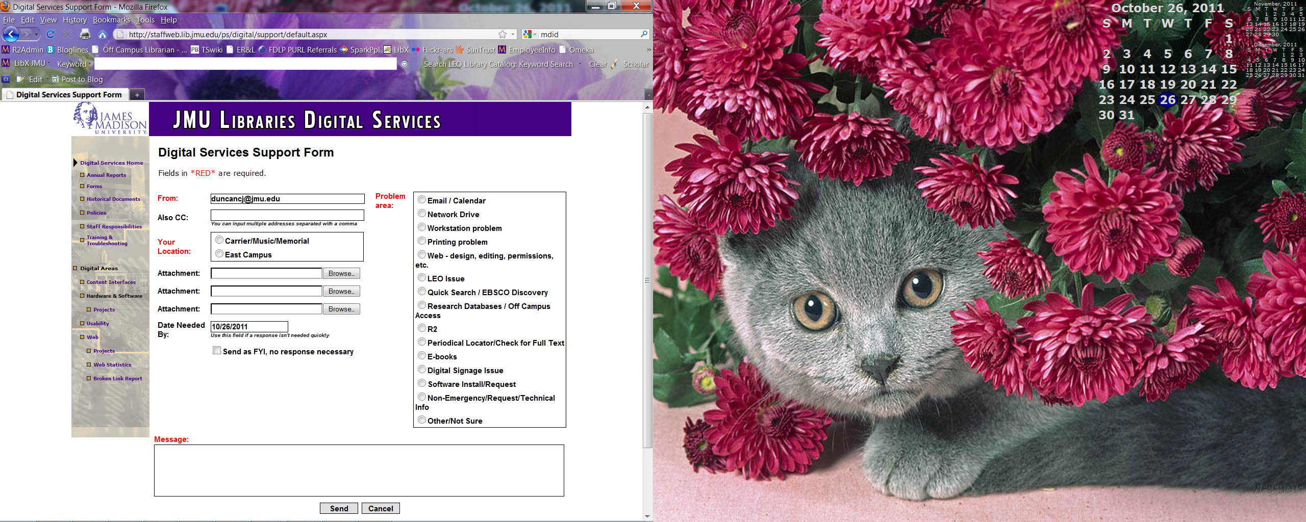

* 1. **Hardware & Software Needs**

Locally we are hosting 2,800 videos on 1.72TB. These are managed through MDID in a collection subset known as the OVC, or Online Video Collection. This collection represents all of the content licensed individually from the distributor, regardless of whether the digital file was created in house or acquired directly from the company. These titles are offered as MPEG-4 files in high and low bandwidth versions and delivered with Flowplayer.

In house digitization is handled by one staff member whose workstation is equipped with a PC with DVD drive, VHS deck connected to a DV deck with DV out to the PC and a DV tape deck. We use the VIDI software for capturing VHS and Handbrake for ripping DVDs. Appendix A contains our in-house workflow document for this process.

Technical specifications vary from vendor to vendor. Some are already offering the latest in streaming technology including mobile device compatibility and dynamic bit-rate switching. An institution should evaluate how they anticipate patrons accessing streaming media and whether a vendor is able to deliver content that suits that model. Important factors to consider would be:

How much staff support and digital storage space the library is able to provide?

Is the bandwidth on campus sufficient to provide uninterrupted access to streams?

Will patrons need to access content on their mobile devices?

Will faculty be streaming content to the classroom?

Will faculty need to include the media in a course management system?

1. **Evaluation** 
   1. **Use Statistics**

Gathering and analyzing statistics has proven to be one of the biggest challenges from a collections standpoint. Films On Demand and Alexander Street Press both offer usage data, however variations in what both companies track and how they track it make it difficult if not impossible to compare. We also track usage statistics in MDID, but again it is difficult to compare this to other data. It is also difficult to determine how usage data from online video should be compared to circulation data from the physical collection. Hit counts are not equivalent to checkouts. Consider the following scenario:

Professor X requests that his students view the film Dreamworlds for class. It appears on the syllabus and early in the semester Student A locates the film in the library catalog and writes down the call number. A couple of weeks before the assignment is due she remembers that she still hasn’t watched the film, but has lost the call number she wrote down earlier. She looks the film up in the catalog again and writes down the call number. Later in the afternoon she comes by the media center to check out the video not realizing the since it’s on reserve she must watch it in the library. She doesn’t have time so she leaves and returns later in the day checks out the film and settles down to watch it. Her friend sees her and comes over to talk, so she pauses the film and restarts it a few minutes later. She needs to go to the restroom so pauses the film again and restarts it when she returns. Student B from the same class sees the Student A watching the film and asks if he can watch it after her except he’s left his id card in his dorm. So Student A lets him watch the film when she’s done and he turns it in a short while later.

This scenario would be reflected as one checkout of the physical copy of the film, however depending on the student’s behavior and how statistics are tracked a similar pattern of use could be reflected as half a dozen or more views of the online video. This illuminates another challenge, which is, it is difficult to analyze user behavior in connection to the use of streaming media. We know a lot about how patrons access and use our physical collections and how to gather appropriate statistics around this, but very little about similar usage of online media content.

Spreadsheets containing a selection of data from both the OVC and Films On Demand are provided in Appendix B and C respectively.

* 1. **User Feedback**

User feedback has been positive, especially from faculty. Many feel that the availability of streaming video has significantly changed how they teach and their ability to include media in their classes. We have not conducted any formal user satisfaction studies at this time.

1. **Future**

Streaming video is here to stay. As students and faculty become more familiar with streaming the demand for this method of delivery will continue to grow. This comes with both advantages and disadvantages. The convenience of accessing media anytime is the most obvious benefit. Purchasing more titles streaming slows the growth of the physical collection reducing the need for new shelving and specialized cases, which can be a significant expense. It requires an investment in digital storage, though, and expertise in digitizing and managing the digital collections. It can also put a burden on bandwidth that campus infrastructure must struggle to meet. Large subscription packages like Films On Demand provides access to a broad range of titles that a library would find difficult to acquire individually. This can be valuable in reaching out to patrons and departments that may not traditionally be heavy media users. It is likely that vendors will be increasingly offering these sorts of packages. Though expensive, they are easier to manage than seeking licenses on a title-by-title basis and streaming in house. However, libraries lose some control over their collections with this arrangement. Titles can be removed from these collections and if the library doesn’t own a physical copy it may leave patrons stranded. Purchasing rights in perpetuity (or life of the format) and maintaining in house access to the material be that a digital file or physical object can protect against this.

Services such as Netflix, iTunes and Amazon Instant are widely used on campuses now and will only increase. Many distributors whose only markets previously were libraries are now making their content available in commercial streaming services such as these. Library users may be more comfortable and familiar with these services and choose to access course material there rather than going through the library’s website. While this will relieve a certain pressure on libraries it will be important to remember that these services are not archives and when titles are no longer profitable and license terms run out they may be taken offline. If patrons have been relying on a title being available on Netflix they may be caught in a bad situation.

The cheap and ubiquitous nature of video creation now, as opposed to the outrageously expensive and specialized process it was only a few years ago has created a booming market in filmmakers who are self-distributing. It is likely this will continue to increase. Self-distributors are both good and bad news for librarians. They are often eager to have their films seen and included in library collections and willing to negotiate reasonable terms. However, they are rarely prepared for the hoops one must jump through in dealing with procurement at the level of a university.

It is also important to know that many distributors are trying to find their way in these new waters just as much as librarians. One shouldn’t be afraid to tell distributors what does and doesn’t work for libraries. This is especially true of the self-distributor, who may have never considered libraries as potential markets for their film. Some distributors are quite intractable when it comes to negotiating licenses; others are much more willing to find middle ground.

Appendix A

**OVC WORKFLOW**

**Acquisitions**

Makes record for order of any title with streaming license

-Millennium sends notice to Cataloging / MRC staff

**Cataloging**

1. Makes Create List in Millennium for new streaming titles
2. Labels new tangible media (DVD) if available, sends with checklist to MRC

**MRC**

Overview:

Video files are transcoded for uploading and related metadata and production notes are added to a spreadsheet. The spreadsheet is saved in standard .XLS format, and then saved again in a .CSV format. The .CSV file is uploaded to MDID3, and then video files are uploaded as well. Cataloging is then notified that they may proceed with the next step (adding links to LEO records). Our notification will be in the form of an email with the .XLS production spreadsheet attached for identification of titles. All copies are archived/saved, and the batch will later be logged in a master spreadsheet (detailed below in later steps).

Details:

* Streaming file creation:

End product is a 300k, 800k, and if an FFH title, a VBR .MP4 as well

-MRC staff will transcode from the highest quality media available (DVD, VHS, digital file delivered by email or hard drive)

* Production Spreadsheet creation:

If available, metadata for new titles are exported from Cataloging’s Create List. Three fields of data are saved to a text file (Title, Call#, Bib #).

Title info is added to an Excel spreadsheet (Title, Call#, Bib#), as well as the MRC ID number for the title (which may be the same as the vendor’s, or created in house if no usable ID number is available). All ID numbers begin with an acronym for the vendor’s name. The spreadsheet is saved as a .CSV file for uploading.

* Uploading to MDID3:

Metadata and video files must be uploaded using management tools in MDID3, permissions set by CIT staff.

Metadata must be uploaded first:

Details:

-Log into MDID3, select Management tab, then “import metadata”

-Browse to the needed .CSV file, select Upload and Analyze File

-Settings should be preset from past uploads. Any change in the spreadsheet for metadata, however, will reset to the default settings, the following are notes on the proper settings: collection (select online video collection), fieldset (any), Separator (keep blank), update existing records (checked), add new records (checked), test import only (unchecked), Personal records (unchecked). Source field column should display needed fields (bib record, call #, mrc id#, title). Map to column should have Dublin Core fields selected (bib record#=relation, Call#=Source, MRC id#=identifier, Title=title). Separate Label column (all checked). Label column, the only necessary label is to enter “LEO Call Number” in the Call# row. Hidden column (check rows for Bib record and MRC id). Order column (should be 1,2,3,4 top row to bottom).

-With settings selected properly, select “import file”, this will open the “manage jobs” page and if the job doesn’t seem to start, refresh the page. Once processed, video files can be uploaded.

Video Files to upload:

-Logged into MDID3, with Management tab selected, select “Import Media Files”

-Collection (select Online video collection)

-Storage (select Online Video Collection low bandwidth, high bandwidth, or downloads, depending on which type of file you are uploading.

Files can be grouped according to type, but must only be named by the resource number. Currently 300k=low, 800k=high, vbr=download.

The MRC workflow will include folders for each type. When being sorted in to the respective folders, for example, the “300k” portion of the filename will have to be deleted. Each title, therefore, will have files in each folder with duplicate names and it will be important to make sure the right file type is in the proper folder. The only other opportunity to check later will be drop-down display for the various file sizes (the bitrate will be displayed, and while the number won’t be exactly 300, 800, etc., the respective difference between the sizes will reveal which is the high vs. low bandwidth).

-Create records, Personal records, and replace files are all left unchecked

-Select “Select and upload files”. This will let you browse to the file locations. You can select multiple files (ex. All files in the 300k folder), but only for one bitrate group (or “Storage” type). Another browser can be opened with another login of MDID3 if you wish to multitask uploading another group.

-Once uploaded the record can be viewed and the video tested. Also the OVC display page can be viewed by navigating to “mdid.cit.jmu.edu/ovc/****, where **** stands for the resource id of the title, ex. Fl001. One or two representative titles should be checked for the batch, but the exhaustive quality control check will occur after Cataloging has added links in LEO.

NOTE: the needed production template, OVC inventory, and archive versions of both, plus archives of .csv files from prior batches will be located on the Media Common share under Streaming Video/OVC.

* Notify Cataloging that the current batch of titles has been uploaded and links can be added to the LEO records. A spreadsheet (TBD, likely the .CSV file of metadata) will be attached to the email notification to verify the list of titles.

**Cataloging**

Creates and adds links in LEO. The link, in the title’s LEO record with open a login, and once logged in, an OVC display page will open displaying:

OVC logo, a drop-down box for any multiple file sizes, a video player, the title and call number, and a link back to the LEO record.

Cataloging staff will notify MRC staff when links are completed for the current batch.

**MRC**

Archiving data and files:

Archival quality video files, if created in house during production, will be saved to an external hard drive for back up, and for any future need for conversion.

Metadata from the current batch’s production spreadsheet (or .CSV file) can be imported into the OVCinventory spreadsheet. In addition the batch date, several quality control checks, and any relevant notes will be logged.

Quality checks include if: archive quality video files have been added to hard-drive storage, links work to and from LEO, and the video plays and looks good. Once checked, the current batch is complete.

**Technical Services**

Staff will monitor streaming video licenses and notify MRC if any titles need to be removed from the collection due to an expired license.

Appendix B

OVC statistics

|  |  |  |
| --- | --- | --- |
| **Title** | **YTD** | **Total** |
| Dreamworlds 3 | 110 | 484 |
| Secrets of the Mind | 120 | 333 |
| Big Bucks, Big Pharma | 1 | 282 |
| Sick in America |  | 178 |
| Playing Unfair: Media Image of the Female Athlete, The | 39 | 169 |
| Richest Man in the World, Andrew Carnegie | 23 | 127 |
| Not for Ourselves Alone: The Story of Elizabeth Cady Stanton and Susan B. Anthony (part 1) | 11 | 123 |
| La Decadencia de un Imperio de los Austrias a los Borbones | 24 | 117 |
| Obeying or Resisting Authority: A Psychological Retrospective | 23 | 115 |
| Sean's Story: A Lesson in Life | 13 | 99 |
| Secret of the Wild Child, | 18 | 92 |
| Killing Us Softly 3 | 17 | 92 |
| AmÃ©rica, un Mundo Nuevo | 22 | 91 |
| Codes of Gender, The | 16 | 84 |
| House of Bernarda Alba, The | 29 | 79 |
| Overspent American, The | 15 | 78 |
| Daguerre and the Photo Camera | 15 | 77 |
| Island of the Color Blind : Monochromatism | 14 | 74 |
| Hispania, un Producto de Roma | 21 | 73 |
| What I Want My Words to Do to You | 13 | 72 |
| King Corn | 13 | 71 |
| Art in the Twenty-First Century Season II: Loss and Desire | 8 | 68 |
| Race for the Superbomb (part 1) | 20 | 66 |
| What a Girl Wants | 7 | 66 |
| Off the Straight and Narrow: Lesbians, Gays, Bisexuals and Television | 6 | 66 |
| Tim Wise on White Privilege | 7 | 65 |
| Tough Guise: Violence, Media, and the Crisis in Masculinity | 9 | 63 |
| Rise of Capitalism, The | 8 | 63 |
| Class Divided | 12 | 61 |
| Art in the Twenty-First Century Season I: Place | 12 | 61 |
| Renaissance and the Age of Discovery, The | 2 | 61 |
| Ragin' Cajun : Usher Syndrome | 10 | 60 |
| One Woman, One Vote | 3 | 56 |
| Battle of the Brains: The Case for Multiple Intelligences | 8 | 54 |
| Killing Us Softly 4 | 4 | 53 |

Appendix C

Films on Demand Statistics

|  |  |
| --- | --- |
| **Title** | **Total Views** |
| Total: | 6832 |
| The Common School: 1770-1890 | 186 |
| As American as Public School: 1900-1950 | 155 |
| Sick in America: John Stossel on Healthcare | 149 |
| El Islam y la Resistencia Cristiana-in Spanish with English Subtitles | 112 |
| The Bottom Line in Education: 1980 to the Present | 106 |
| A Struggle for Educational Equality: 1950-1980 | 103 |
| No Vacancy: Global Responses to the Human Population Explosion | 102 |
| La Nueva Espana de Felipe V-in Spanish with English Subtitles | 81 |
| Beyond F.A.T. City: A Look Back, a Look Aheadâ€”A Conversation about Special Education | 81 |
| Charisma in Politics: Analyzing Body Language | 77 |
| Hispania, un Producto de Roma-in Spanish with English Subtitles | 67 |
| The Quality Gap: Medicine's Secret Killer | 65 |
| Comrade Kamprad: IKEA Goes to Russia | 63 |
| A World Apart: Global Inequality and its Consequences | 62 |
| The Great Depression | 62 |
| Through a Child's Eyes: Views of Global Poverty | 57 |
| The Unelected: The Media | 56 |
| The War on Drugs: Winners and Losers | 52 |
| The Immune System | 46 |
| La Decadencia de un Imperio de los Austrias a los Borbones-in Spanish with English Subtitles | 45 |
| How Many People Can Live on Planet Earth? | 40 |
| The Politics of Trees | 35 |
| The 5 Communication Secrets That Swept Obama to the Presidency | 34 |
| Racial Stereotypes in the Media | 33 |
| Facing the Challenge: Building Peer Programs for Street Youth | 32 |
| Bacterialand | 32 |
| Albert Einstein and the Theory of Everything | 30 |